Department of Microbiology

484 West 12th Avenue
Columbus, OH 43210-1292

Phone (614) 292-2301
Fax (614) 292-8120

January 24, 2011

Professor Larry Krissek
Chair, Arts and Sciences CCI
Re: Zoology BS and BA

Dear Professor Krissek:

At the December 15, 2010 meeting of the Mathematics and Social, Behavioral, and Natural Sciences CCI Subcommittee the semester conversion plans for the Zoology BS and BA programs, submitted by the Department of Evolution, Ecology, Organismal Biology (EEOB), were reviewed.

In preparation for the transition to semesters, EEOB initiated reviews of all areas of research and teaching covered in the department. These reviews resulted in revised learning goals and course restructuring that impacted both undergraduate and graduate programs; consequently, the BS and BA programs in Zoology were presented as re-envisioned.

Under the semester schemes for these degrees, students will satisfy requirements in five core areas: evolution, ecology, genetics, biodiversity, and organismal biology; a sixth topic area, cellular and developmental physiology, was dropped from the semester core. The first three areas (evolution, ecology and genetics) are satisfied by a required core and students can choose from a wide range of courses to meet the requirements in the remaining two areas. The Zoology BS and BA degree programs have slightly reduced requirements for mathematics and organic chemistry under semesters; in both areas a two-quarter series required under quarters will be replaced by a one-semester course during semesters. Both semester programs will however, require one-semester of statistics. BS and BA programs are closely related, with the BA program differing only in its supportive mathematics requirement.

The committee felt that the proposals were carefully prepared and covered all of the essential topics. We requested a few minor text revisions for clarification, and we unanimously approved both proposals for the next step in the approval process.

Sincerely,
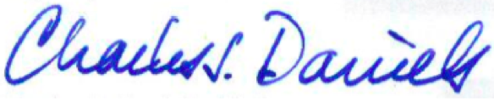

Charles J. Daniels, Ph.D.
Professor
Acting Subcommittee Chair for Dec. 15

